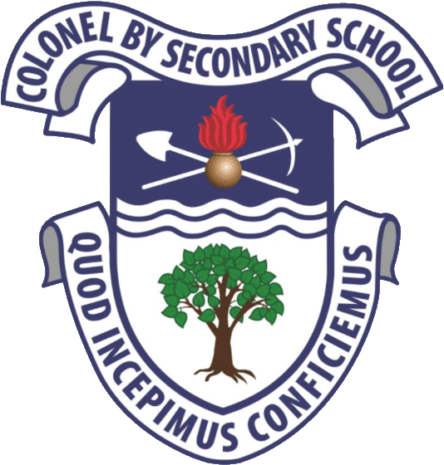
Colonel By Secondary School
Ottawa-Carleton District School Board
Fine Arts Department

Course Title: IB Music
Course Code: AMU3ME, AMU4ME
Grade Levels: 11-12
Teachers: Mr. Richardson
Website: https://mrkrisrichardson.wixsite.com/teacher
Course Description:
The aim of the course will be to help students recognize and articulate musical elements realized in diverse examples, as well as areas of performance and investigation of musical knowledge. The course will teach the importance of music in historical terms and also as a medium of self-expression and as a tool for better understanding people across the world. These course goals are aimed specifically with the idea of the International Baccalaureate learner profile in mind. The course will encourage students to become more interested and sensitive to musical worlds by exploring the social, historical, and cultural influences of music.

IB Music Goals:
Through studying any of the group 6 subjects, the arts, students become aware of how artists work and communicate and enable students to:
1. Enjoy lifelong engagement with the arts
2. Become informed, reflective and critical practitioners in the arts
3. Understand the dynamic and changing nature of the arts
4. Explore and value the diversity of the arts across time, place and cultures
5. Express ideas with confidence and competence
6. Develop perceptual and analytical skills

IB Assessment Component Weighting and Evaluation
The IB portion of this course will consist of internal and external assessment:

Internal Assessment - 50%
This component is internally assessed by the teacher and externally moderated by the IB at the end of the course.
Group performing - A recording selected from pieces presented during two or more public performances, 20–30 minutes (20 marks)

External Assessment – 50%
Students choose one of the following options.
- Exam - Listening paper (2 hours) 30%
- Musical links investigation 20%
A written media script of no more than 2,000 words, investigating the significant musical links between two (or more) pieces from distinct musical cultures

The Ontario Curriculum portion of this course will consist of ongoing daily assignments and activities in the following areas:

Unit 1 - Fundamental Theory of Music Perception and Analysis
1. Study of prescribed works
2. Study of music genres and styles
a. The elements of music
b. Musical structure, function, and expressive characteristics
c. Music terminology and notation
d. Overview of music historical periods

Unit 2 - Music History Perception and Analysis: Early music through the
Renaissance
- Musical Investigation and research: topics submitted for independent work
- Performance: Presentation of IB recital pieces
3. Composition: Assessment of basic notation devices

Unit 3 - Music History Perception and Analysis: Baroque through early Classical
- Musical Investigation and research: topics submitted for independent work
- Performance: Presentation of IB recital pieces
- Composition: Overview of compositional styles of Baroque and Classical periods
- Assessment of completed student work

Unit 4 - Music History Perception and analysis: Late Classical and Romantic
periods
- Musical Investigation and research: topics submitted for independent work
- Performance: Presentation of IB recital pieces
- Composition: Overview of compositional styles of late Classic and Romantic periods. Assessment of completed student work

Unit 5 - World Music Perception and Analysis
- Historical and Cultural contexts: Nationalism, World music, 20th Century and modern music
- Musical investigation and research: topics submitted for independent work
- Composition: Overview of compositional styles for world music, 20th Century and modern music.
- Original student pieces in written and recorded form to be presented and turned in.

Unit 6 - Jazz, Ethnomusicology, listening analysis and essay writing, recitals
- External assessment exam review
- Internal assessments: recitals, concerts, group performances, fine arts critique, composition analysis and review for both written and recorded work

ONTARIO ASSESSMENT AND EVALUATION

CURRICULUM: Students will be evaluated using the major strands and overall expectations summarized below. By the end of the course students will:

A. CREATING AND PERFORMING
A1. The Creative Process: apply the stages of the creative process when performing notated and/or improvised music and composing and/or arranging music;
A2. The Elements of Music: apply elements of music when performing notated and improvised music and composing and/or arranging music;
A3. Techniques and Technologies: use a variety of techniques and technological tools when performing music and composing and/or arranging music.

B. REFLECTING, RESPONDING, AND ANALYSING
B1. The Critical Analysis Process: use the critical analysis process when responding to, analyzing, reflecting on, and interpreting music;
B2. Music and Society: demonstrate an understanding of how traditional, commercial, and art music reflect the society in which they were created and how they have affected communities and cultures;
B3. Skills and Personal Growth: demonstrate an understanding of how performing, creating, and critically analysing music has affected their skills and personal development;
B4. Connections Beyond the Classroom: identify and describe various opportunities for continued engagement in music.

C. FOUNDATIONS

C1. Theory and Terminology: demonstrate an understanding of music theory with respect to concepts of notation and the elements and other components of music, and use appropriate terminology relating to them;
C2. Characteristics and Development of Music: demonstrate an understanding of the history of various musical forms and of characteristics of music from around the world;
C3. Conventions and Responsible Practices: demonstrate an understanding of responsible practices and performance conventions relating to music.
Assessment and Evaluation:
The assessment of a student’s progress will incorporate both process and product.
Process assessment will include the student’s day-to-day behaviour, cooperation and participation, effort in class, attendance and punctuality, evidence of home practice, etc.
Product evaluation is determined using the following procedure: term work comprises 70% of the final mark and end of year summative evaluations comprise 30% of the final mark.
A variety of term assessment and evaluation tasks will be used such as unstructured and structured observations (performance evaluations), class discussions, peer and self-evaluation, presentations, oral debate, journals, written theory and music history assignments, etc.
Throughout the year, students will be assessed on curriculum expectations, receive feedback on learning, and be given opportunities to improve performance within each of the strands of the course, across the various learning categories. The marks are based on demonstration of the overall expectations and will be combined to form the term grade.
Towards the end of the course, students will complete a summative evaluation that will address the overall curriculum expectations for the various strands of the course. This task will be divided into smaller components for ease of completion. The total of the evaluation will comprise 30% of the final grade.
EVIDENCE OF STUDENT ACHIEVEMENT
Evidence of student achievement will follow the Triangulation model which may include observations, conversations with students, and from student performance tasks and products. A balanced combination of a student’s Knowledge and Understanding, Thinking, Communication, and Application will be assessed. These 4 categories will not be separately evaluated. Instead, they will be “considered as interrelated, reflecting the wholeness and interconnectedness of learning.” – from the Ontario Ministry of Education curriculum documents.
Triangulation Sources  of Evidence |  | Description
Observations |  | The teacher may record evidence of student achievement observed as students work on investigations in class.
Conversations |  | The teacher may record evidence of student achievement elicited during a conversation with a student
Products | Tests | There may be major unit tests.
 | Assignments | Students may complete in-class assignments.
 | Performance Tasks | Students may demonstrate their creativity, knowledge and understanding of the material through in-class performance tasks.
 | Summative Task | Students will show evidence of their learning by performing a task that will include many overall expectations of the course.

COURSE WORK 70%
Student products in music may include tests, assignments, performance tasks, and summative evaluations:

- Practicing Instrument
- Individual and Group Performances
- Ear Training
- Theory Lessons and Quizzes
- Sectional Rehearsals
- Composition and Arranging
- Listening and Analysis
- Concert Critiques
- Peer and Self-Evaluation
- Score Analysis
- Sight Reading
- Journals
- Practice Logs
- Class Dialogue
FINAL EVALUATION TASKS 30%
- Final Evaluation – Theory/Analysis/Composition Assessment 10%
- Final Evaluation – Solo or Group Recital 20%

